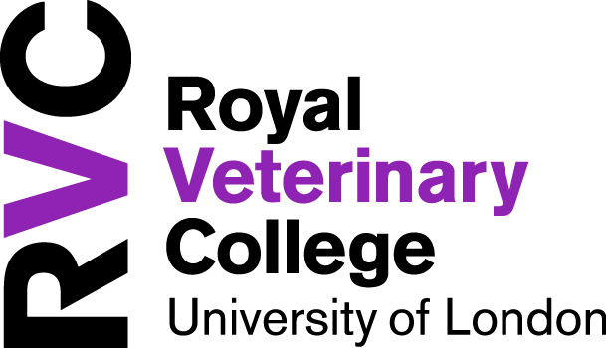

CONDITIONS OF EMPLOYMENT CSS-0118-23

This position is subject to your eligibility to work in the UK.

This is a part-time permanent post.

The appointment will be made on the RVC ’s pay structure, Grade 3/4, £29,083 to £34,905 pro rata, per annum inclusive of £3,725 pro rata, per annum London Weighting and £2,194 pro rata, per annum, Nursing Allowance. You should expect to start at the bottom of the salary scale, except in exceptional circumstances where your skills, knowledge or experience is likely to bring significant advantages to the RVC.

Normal working hours will be 14 hours per week, various shifts, Monday and Tuesday, with 1:4 weekends. This may vary from time to time in consultation with your line manager.

The annual leave entitlement is 30 working days pro rata, per annum plus Bank Holidays and concessionary days, pro rata, offered over the Christmas Closure period (usually 3 days between Christmas and New Year). Due to the nature of our service, you may be required in your post to cover during Bank Holidays and the Christmas Closure period, if this is the case the concessionary days will be added to your annual leave. All holiday is to be taken at a time agreed in consultation with your line manager.

You will be eligible to join the Superannuation Arrangements of the University of London Scheme (SAUL).

This post is based in the UK. You will be based at our Hawkshead Campus but may be required on occasion to work at our Camden Campus.

The College has a “no smoking” policy. Smoking is only permitted in certain designated areas of the College campus.

HOW TO APPLY

For further information and to apply online, please visit our website www.rvc.ac.uk
quoting CSS-0118-23

Closing date: 18 June 2023
Interviews are likely to be held on: 3 July 2023

